Phase I and Phase II Results – Florida (FL)

- Introduction

The economics of the Florida real estate market is different from other states, especially the other bubble states such as California and Arizona. There are three main differentiations to point out: (1) international investors, (2) concentration of luxury million$ homes, and (3) abundance of vacation homes.

First, Florida’s housing market has a large percentage of international investors, and is ranked first of all foreign home-buying transactions at 26%. California, the second-ranked state, is more than 10% below Florida. Table I.1 shows the top five states for foreign home buyers, as compiled by the National Association of Realtors. Most of Florida’s housing’s international investors are from Europe and Latin and South America. Florida is a major gateway for visitors to the United States from other countries, and cash-rich international investors are attracted to the location, climate, and relatively cheap housing properties of Florida. This extra source of investors can buffer against any downward housing price pressure.

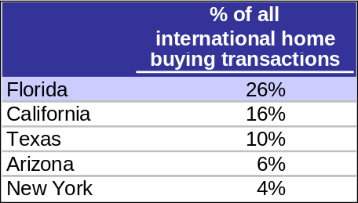
Table I.1: Top Five State Destinations for International Home Buying

Second, Florida has some of the priciest homes in the nation with a large concentration of homes pass the million-dollar mark. These wealthy owners are less affected by the mortgage of credit problems that other Americans face. However, it is important to note that the OFHEO Housing Price Index does account for any homes greater than a value of $417,000. Nevertheless, the abundance of luxury homes attracts wealthy homeowners who may own other homes as well.

Finally, many Americans own vacation homes in Florida, which keeps a healthy stream of demand for houses. Florida is consistently ranked in the top three of an annual poll conducted buy Harris Corporation as where most people would like to live as shown in Table I.2. Furthermore, people who own a vacation home are less likely to take on a speculative mortgage or a mortgage they cannot afford. These owners tend to have more cash than the average homeowner.

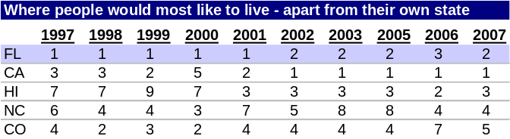
Table I.2: Harris Poll’s “Most Desirable Places to Live” Annual Survey

These characteristics of Florida’s housing market act as a safeguard for the prices of Florida houses, especially in times of declining prices.

B. Plot of Lagged Predictors vs. HPI (simple returns)

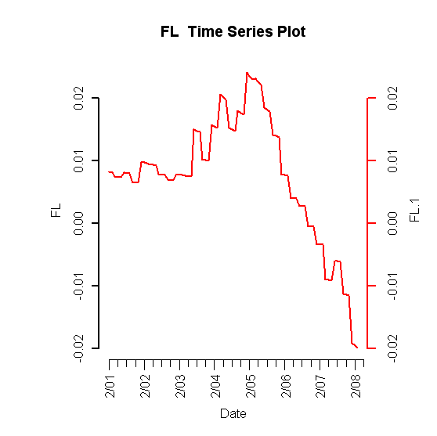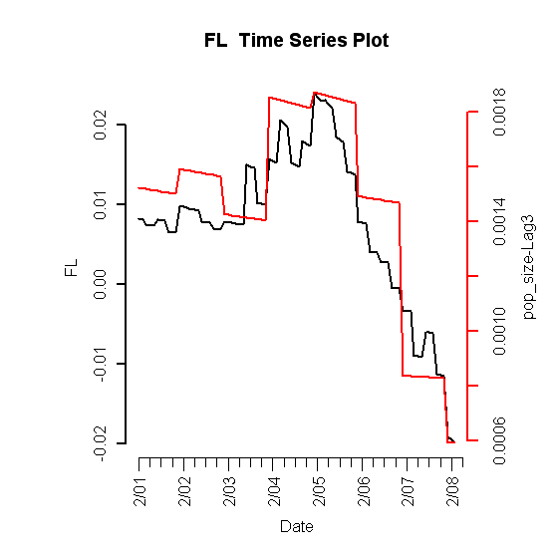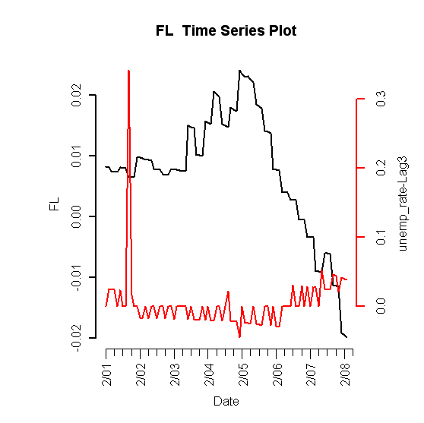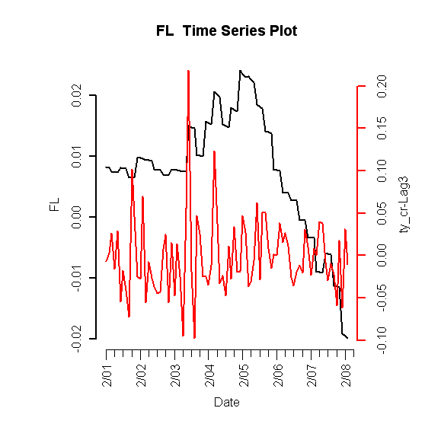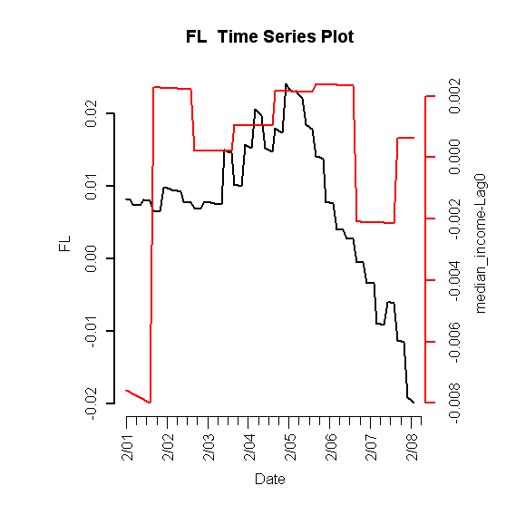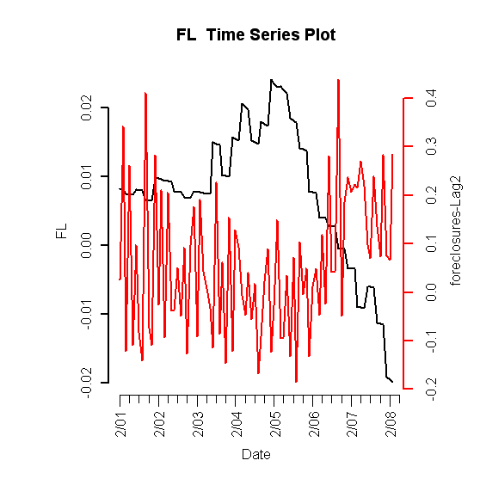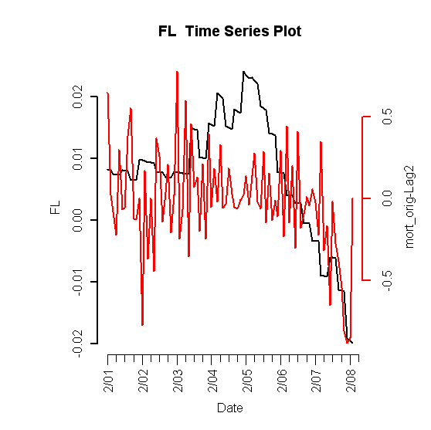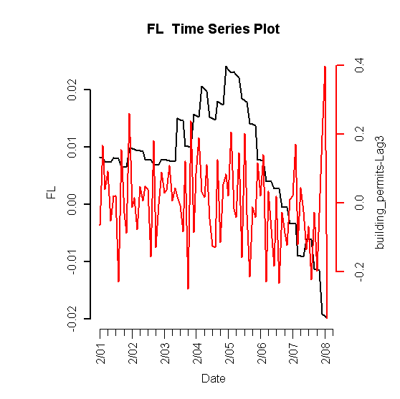
Figure I.1: Lagged predictors vs. Florida HPI

C. Final Multivariate Model

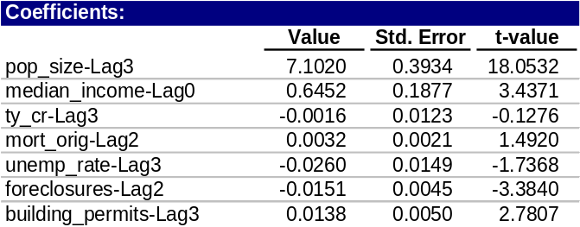
Table I.3: Fitted drift model

1. Phase I: Drift Model

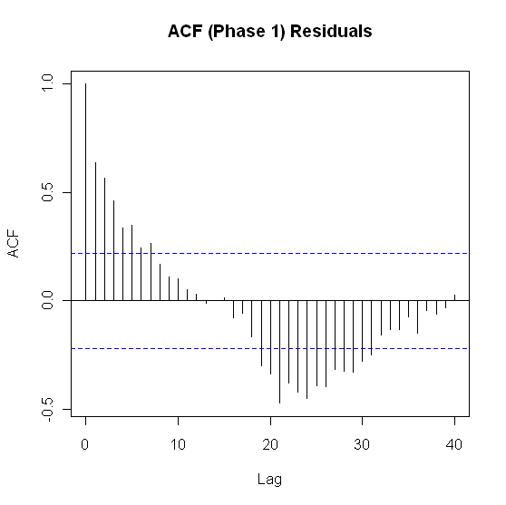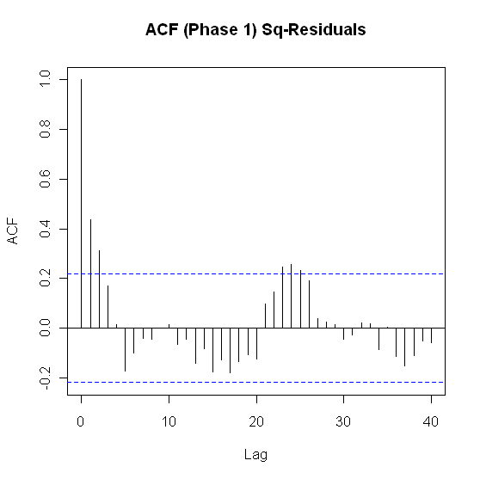
Figure I.2: ACF of residuals (left) and squared residuals (right) of fitted linear model

2. Phase II: Volatility Model

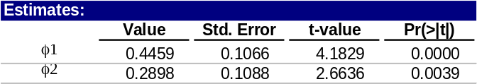
Table I.4: Florida fitted volatility model

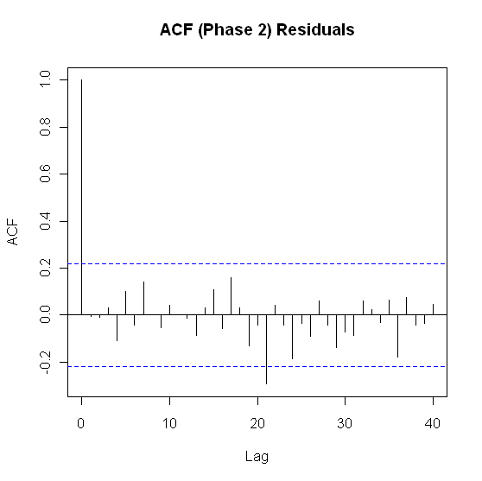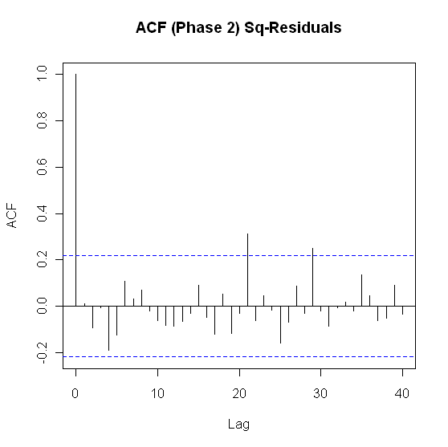
Figure I.3: ACF of residuals (left) and squared residuals (right) of the Phase II model for Idaho

3. Model Checking Diagnostics

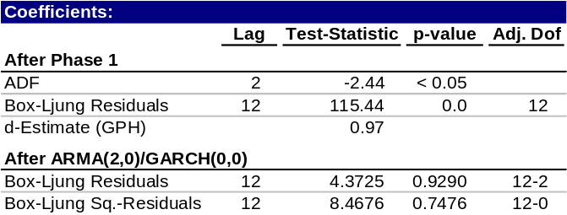
Table I.5: Statistical test results for complete model

D. Fitted vs. Actual Plots

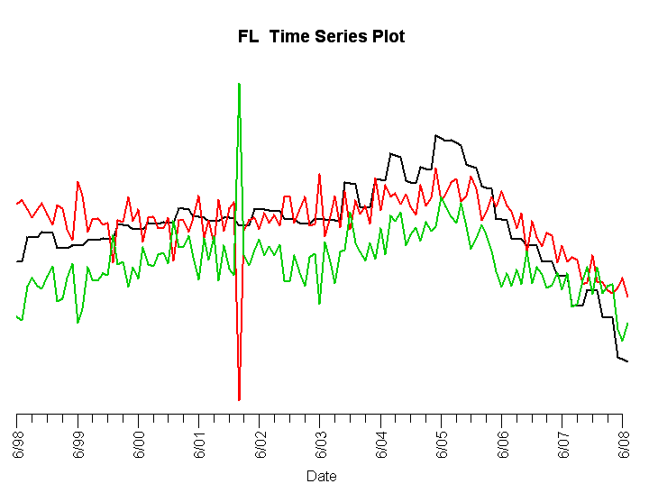
Figure I.4: Fitted Phase I (red) vs. Florida HPI and residuals (green)

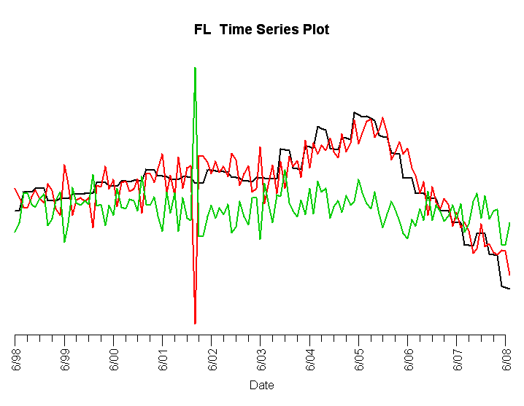
Figure I.5: Complete fitted model (red) vs. Florida HPI and residuals (green)

Figure I.4 and Figure I.5 show that the fitted models provide a good fit for the simple returns of Florida’s HPI, with the exception of a spike in late 2001. This is due to the dramatic and unexpected rise in unemployment due to the 9/11 terrorist attacks. Florida was more negatively affected by September 11 since one of its core industries, tourism, was strongly impacted. Neither the drift nor volatility models are able to capture this anomalous event.

E. Forecasts

Population size has historically had a large effect on the state’s housing prices before the housing bubble, and foreclosures less of an effect. Going forward, demand for housing will be less influenced by growing population size, and supply for housing measured by amount of housing inventory is expected to be more effected by foreclosures. To account for this difference in the supply and demand dynamics, an adjustment was made to these variable’s forecasts, and hence this altered the final forecast for Florida’s HPI.

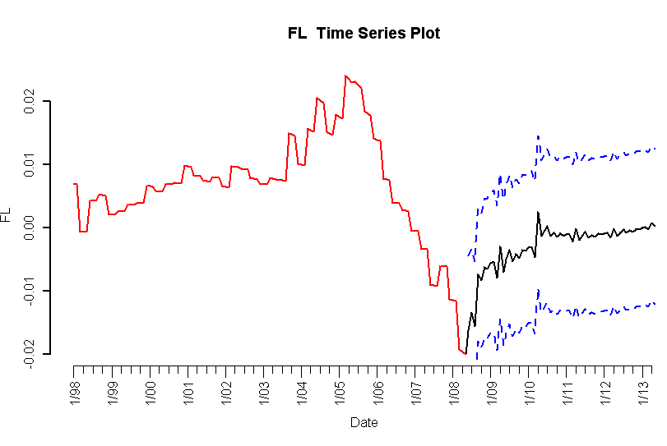
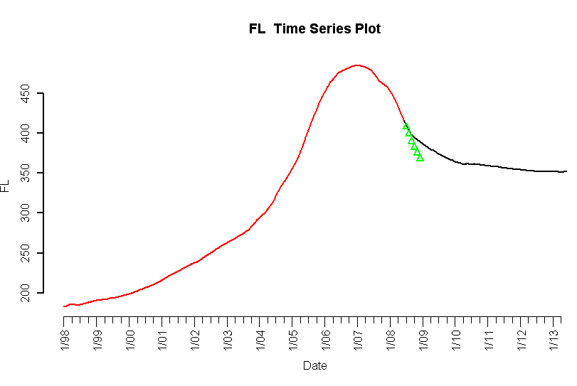
Figure I.6: 5-year forecasted simple returns (top) and forecasted HPI (bottom)

F. Interpretation of Forecasts

The forecast for Florida shows continued decreasing prices, but at slower rates until the end of 2009, and a recovery in mid 2010.

Amongst the bubble states, our forecast and outlook for Florida is quite positive. There are optimistic outlooks for Florida’s population growth, unemployment rate, median income, and housing inventory, all of which are important predictors for Florida’s future housing prices.

Florida’s housing market peaked in 2005, before any other state in the U.S. Many real estates experts and analysts believe that Florida will also be the first to see a recovery as well. A popular expression for this belief is “First in, first out.”

Population growth is estimated to remain strong for the state. By 2010, Florida is forecasted to be the third most populated state in the nation. Florida’s population is expected to increase about 75% by 2030. An estimated 900 people move to the state every day.

Florida has the 4th largest labor force and its unemployment rate has been historically below national average for the past decade as shown in Figure I.7.

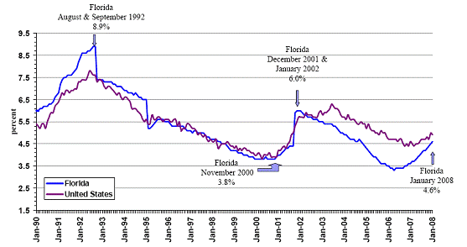
Figure I.7: Seasonally Adjusted Unemployment Rates

Florida also has no state income tax. This gives an extra boost to median income, which has a positive relationship with housing prices.

There have been current signs of inventory reduction. Despite the fact that hundreds of foreclosed properties go on the market each month, the inventory of houses for sale is shrinking. There is current 12-month supply of inventory, down from a peak of 30 months. 3-6 months supply is typical of a healthy housing market.

Furthermore, steep price declines have encouraged first-time homebuyers with good credit, and lots of investors. Cash-rich international investors are also taking advantage of the depressed prices. First and second quarter 2009 has seen housing prices beginning to flatten out.

